
a
Company
Logotype

Cone Beam Computed Tomography- Report



Porur Dental X-rays & CBCT

Patient Name : Mrs. Saamundeeswari | Date of Report : 25.03.2024
Age/ Gender : 60 years/ Female | Region of Interest : CBCT Maxilla
Referring doctor: Dr. Subramoniam | Indication : Implant assessment
Clinical Notes: Nil
PATIENT INFORMATION

CBCT- Full Skull provided
CBCT – IMAGE DETAILS

RADIOGRAPHIC INTERPRETATION

- Completely missing crown and root portion in relation to 12, 14, 17, 28.
- The maxillary alveolar ridge is present with normal trabecular pattern.
- In relation to the left maxillary sinus, presence of mucosal thickening along the medial wall extending to the floor of the sinus is evident.
- Presence of bone loss, extending upto and beyond the middle third of roots in all the maxillary teeth is evident.
- The nasal passage in relation to the right side is narrow compared to the left side. Deviated nasal septum towards the right side is evident.

IMPLANT ASSESSMENT

 | 11 region | 12 region | 13 region | 14 region | 21 region | 22 region | 23 region | 24 region
Sub-Crestal | 4.43 | 6.3 | 7.13 | 6.13 | 5.6 | 6.38 | 6.92 | 7.27
Mid- Crestal | 4.2 | 7.14 | 7.06 | 6.86 | 6.02 | 6.17 | 7.02 | 7.94
Distance between the alveolar ridge and Floor of the Nasal cavity (in mm) | 6.85 | 5.31 | 11.34 | 6.96 | 8.08 | 8.64 | 9.32 | 7.74

 | 15 region | 16 region | 17 region | 25 region | 26 region | 27 region
Sub-Crestal (in mm) | 6.63 | 10.82 | - | 6.38 | - | -
Mid- Crestal (in mm) | 7.03 | 12.03 | - | 8.05 | - | -
Distance between the alveolar ridge and floor of the maxillary sinus (in mm) | 7.68 | 5.19 | 1.36 | 4.43 | 1.49 | 2.38

RADIOGRAPHIC IMPRESSION

- Partially edentulous maxillary arch.
- Generalized chronic periodontitis.
- Left maxillary sinusitis.

Kindly correlate with clinical findings


IMAGES FOR REFERENCE

RECONSTRUCTED PANORAMIC VIEW
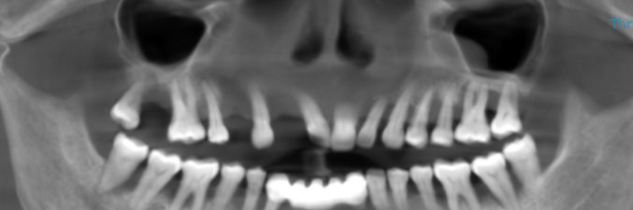

3-DIMENSIONAL VIEW

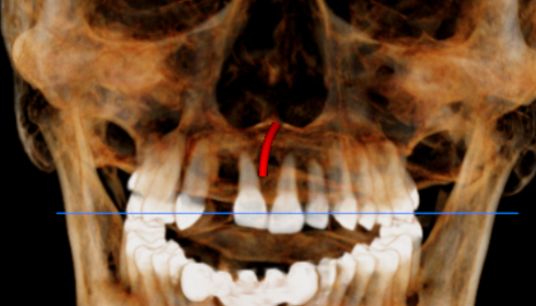

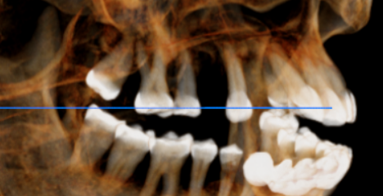
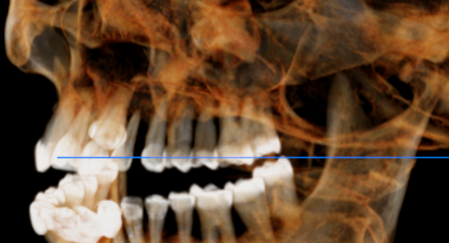

CROSS SECTIONAL VIEW

11 region | 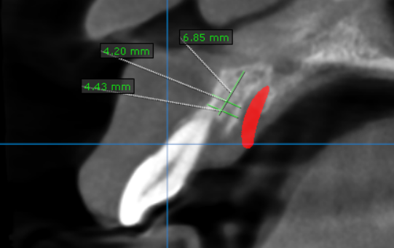
12 region | 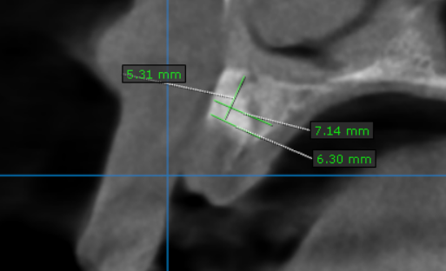
13 region | 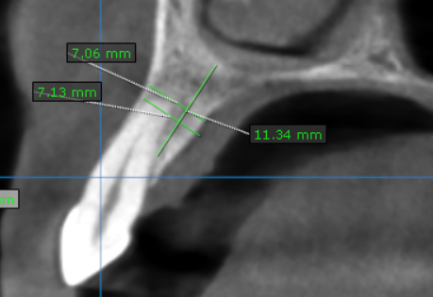
14 region | 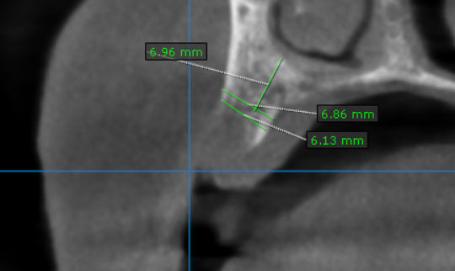
15 region | 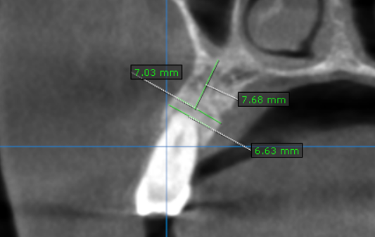
16 region | 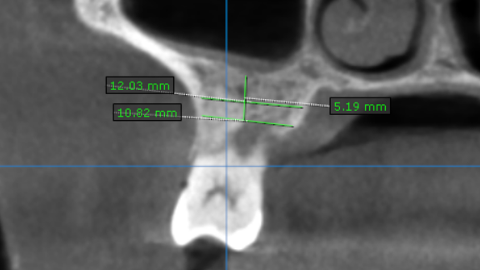
17 region | 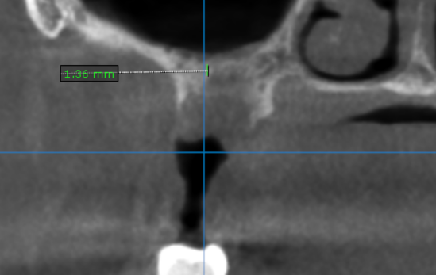
21 region | 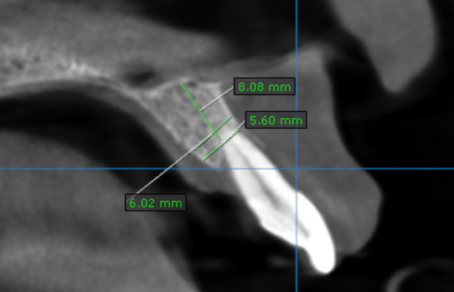
22 region | 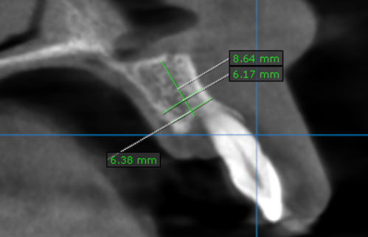
23 region | 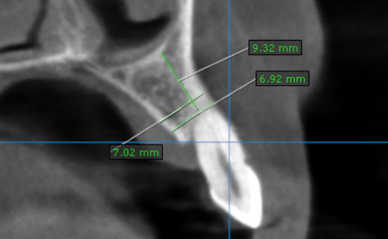
24 region | 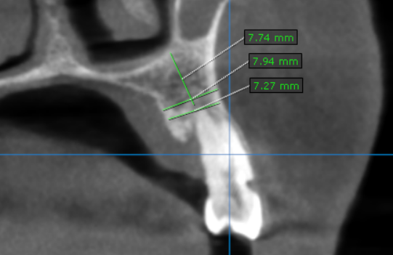
25 region | 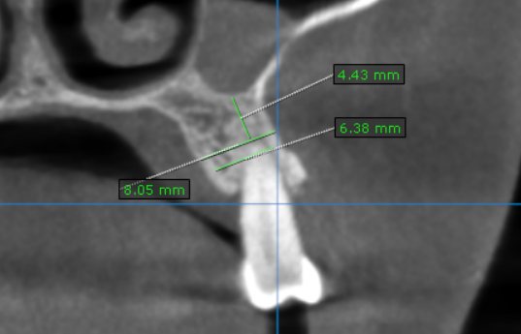
26 region | 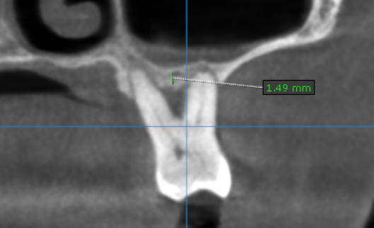
27 region | 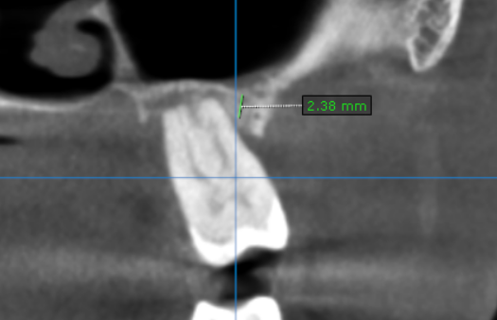

**** End of report ****

